20CYS281 – Operating Systems Lab

Lab 1 - Practice Exercises

G. kushal reddy Gundala

cb.en.u4cys21021

1. Create a folder "20CYS281"

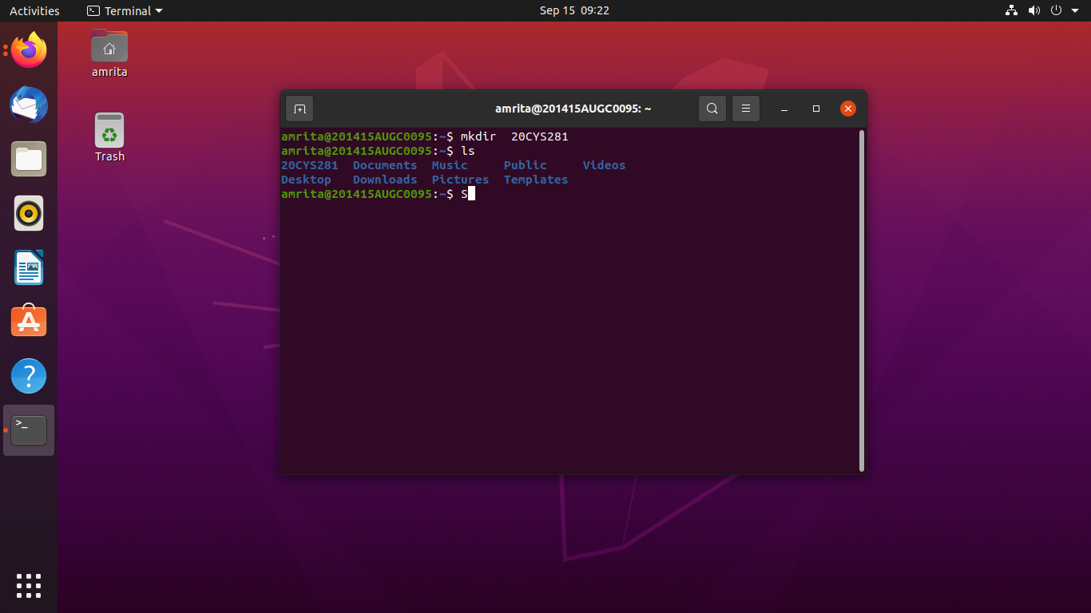

2. Inside the created folder, please create a file with the name "<>.txt" using any editor.

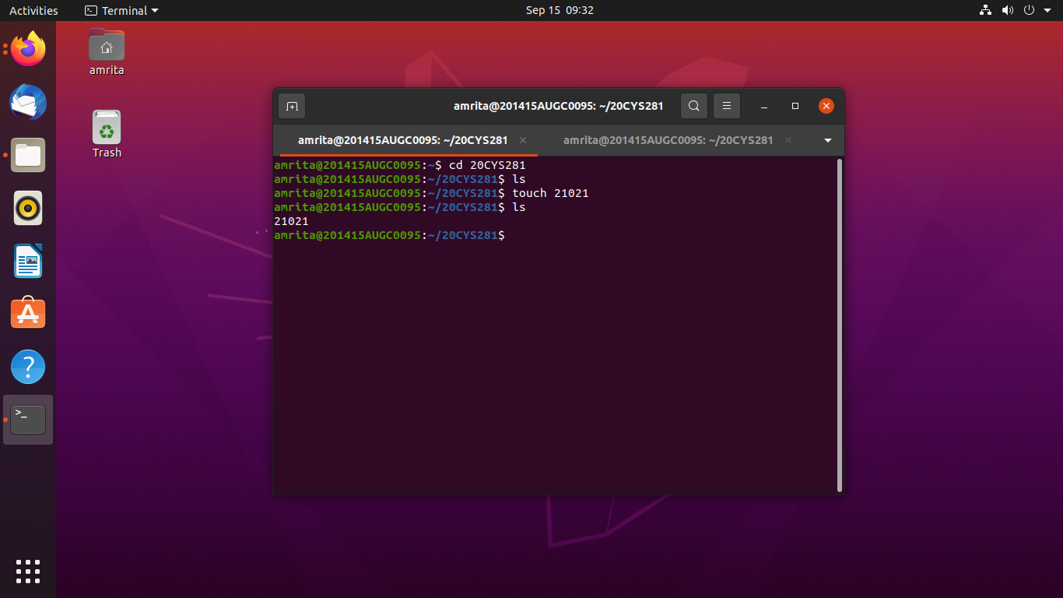

3.Using the command-line editor, please add a short profile about you (3 lines maximum) and save the file

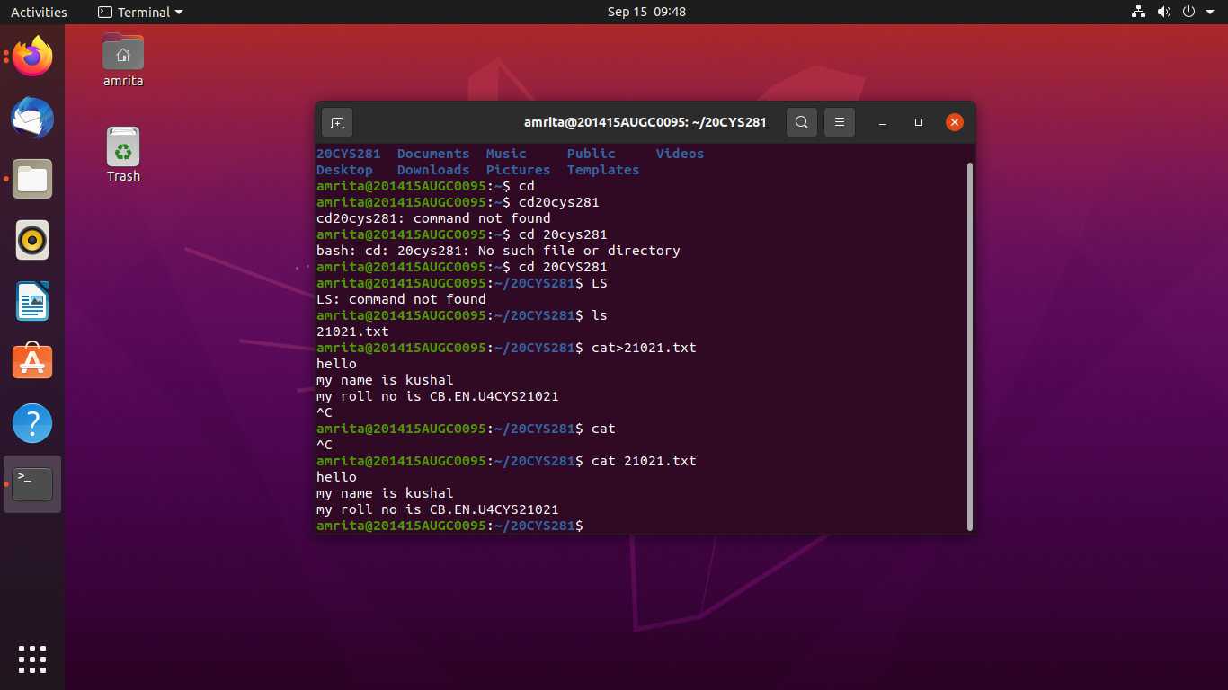

4. Create a folder called "Lab" inside the folder "20CYS281".

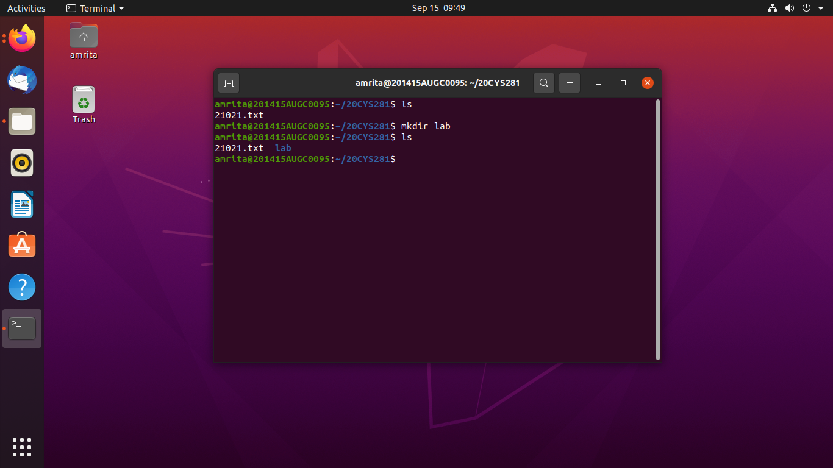

5. Copy the file created (file name will be your Roll Number) to the “Lab” folder with the name "Copied_file.txt".

6. Change the Directory to the “Lab” folder.

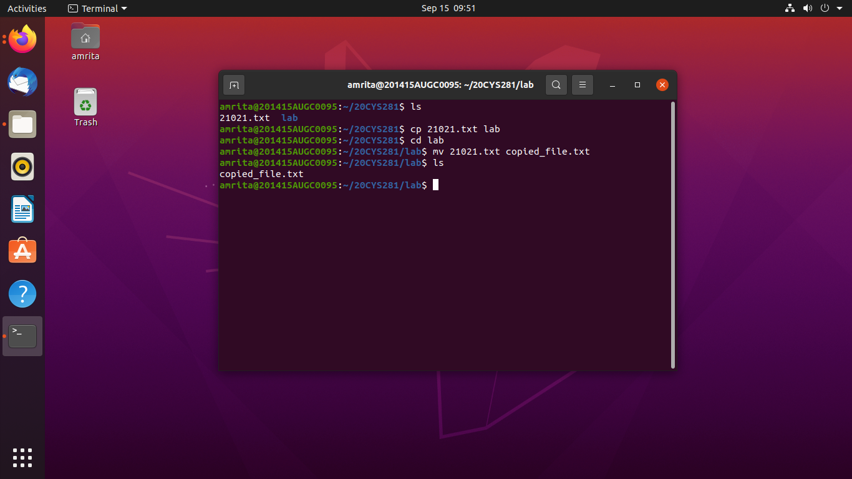

7. Change the permission of the "Copied_file.txt" where there is ONLY write permission for the owner.

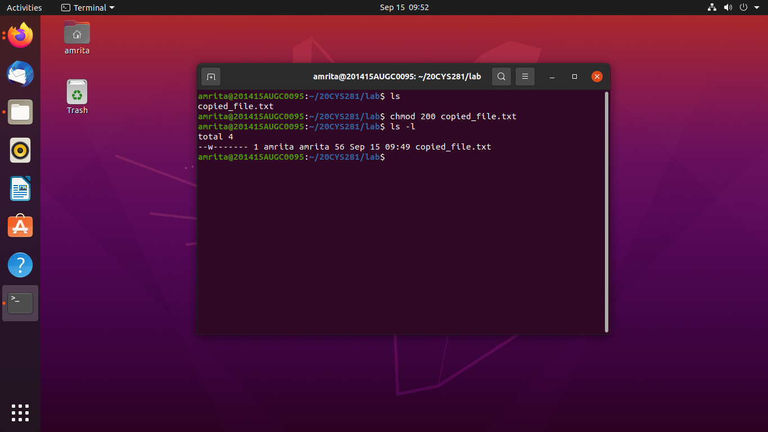

8. Find out the list of processes running in your machine.

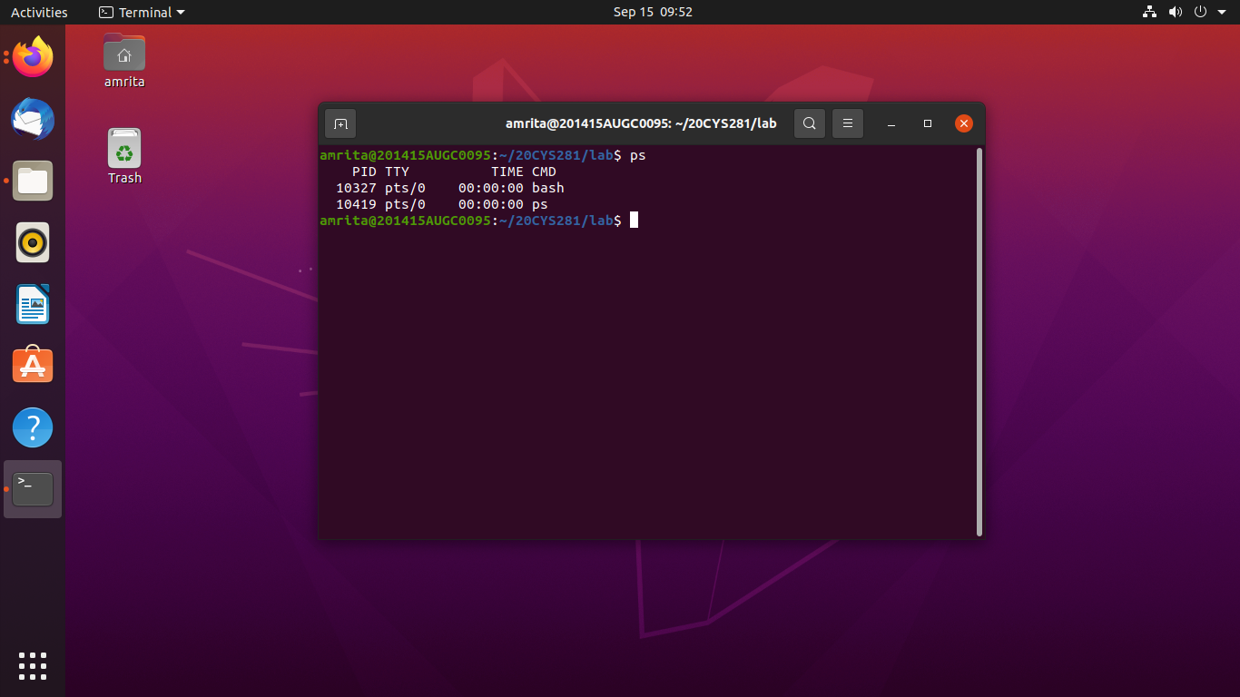

9. Print the contents of the file in your current directory.

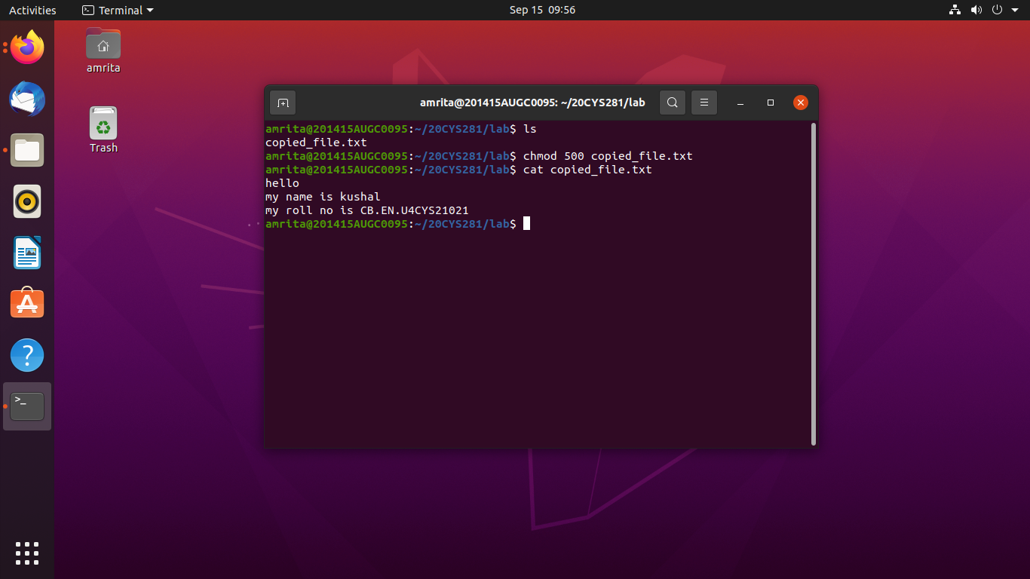

10Find the IP address of your machine and append the address to the file in your current directory.

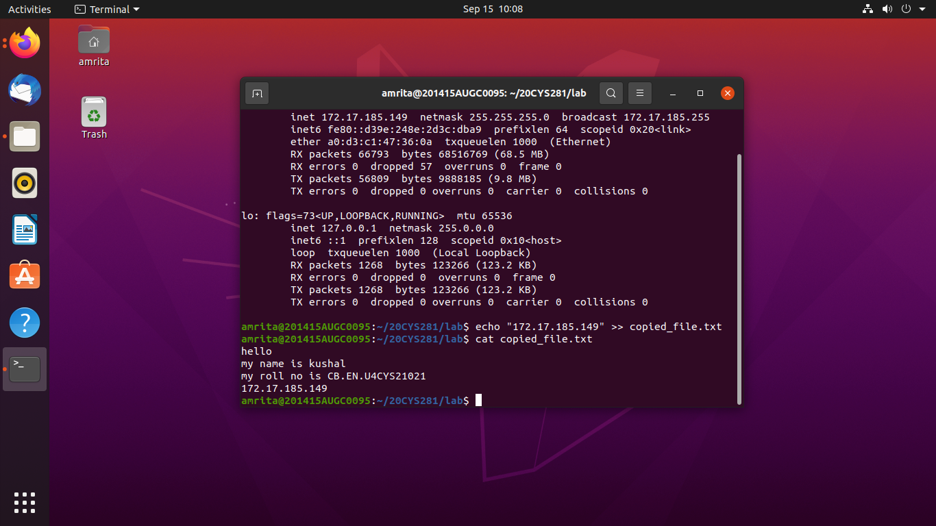

11. Print your current path.

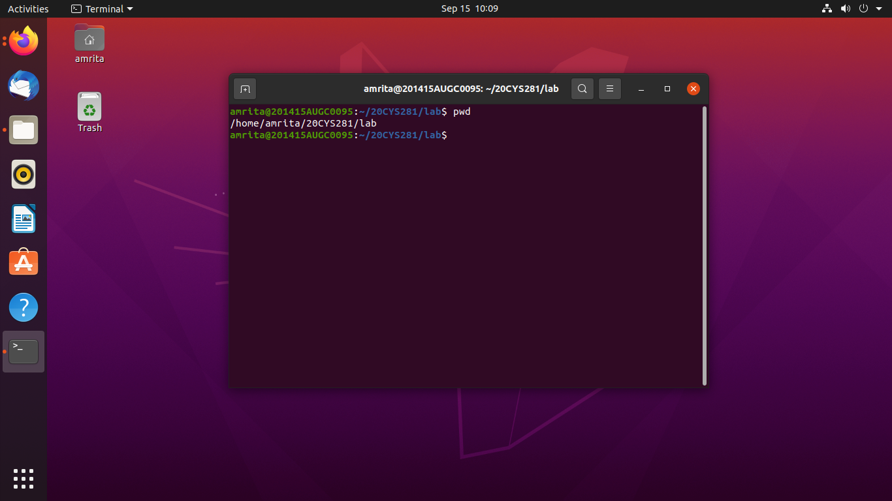

12. Find whether the text “amrita” is available in the file you create

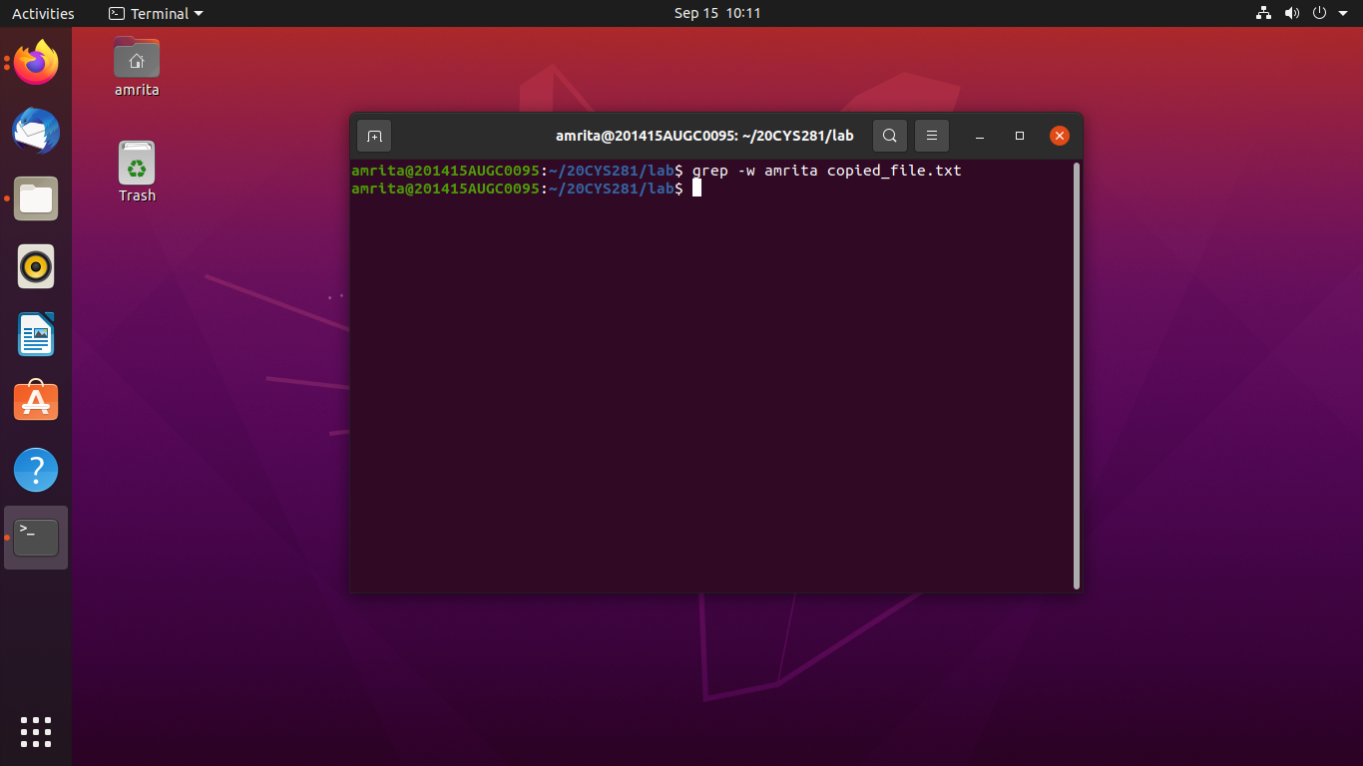

13. Change the ownership of the file to “root”.

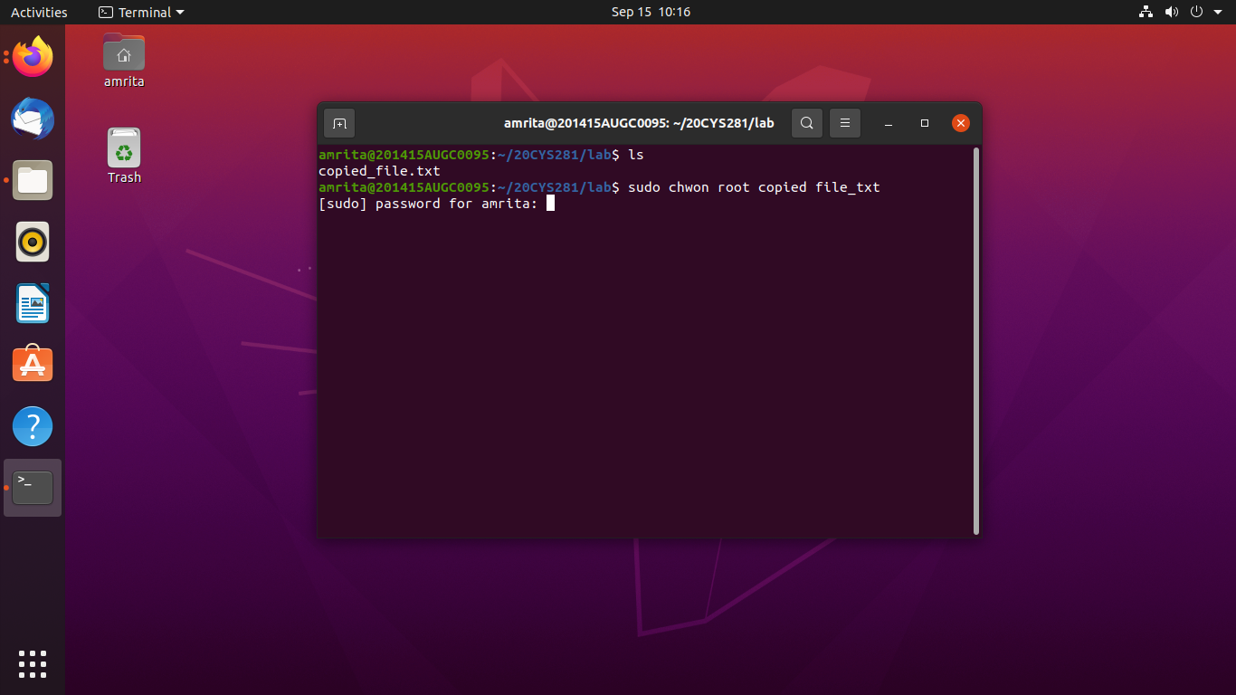

14. Install “git” from the repository to this system.

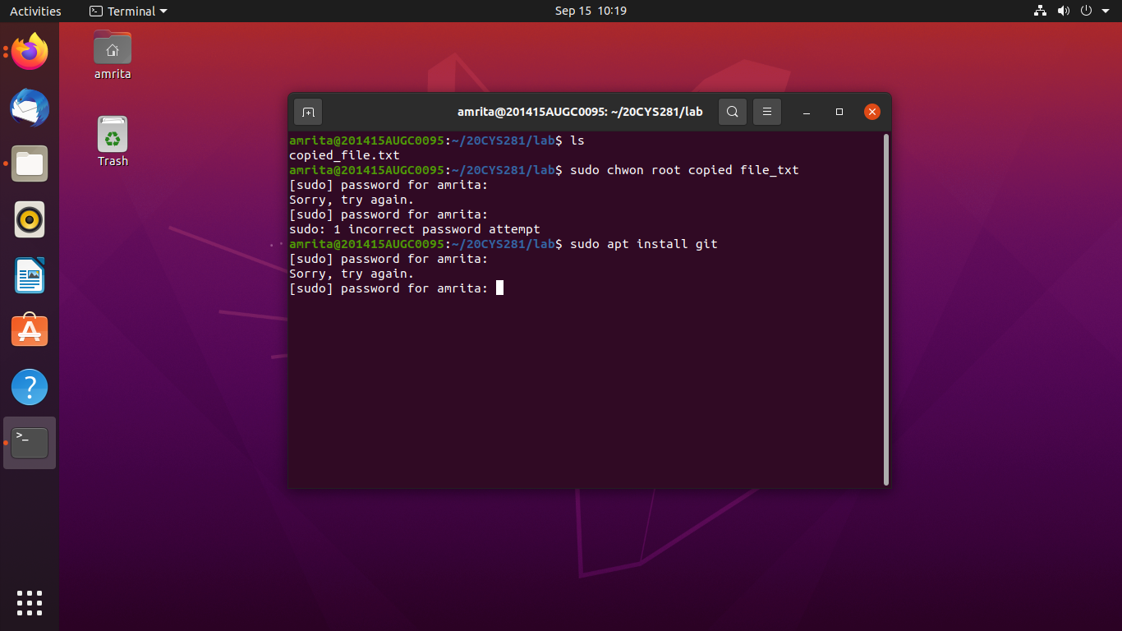

15. Find the purpose and the syntax of the command “iwconfig”

